Task 2 Test

Highscore test:

The highscore will be tested by checking if the highscore is the same number after resetting the game, once a pickup object has collided with the player.

Before resetting:

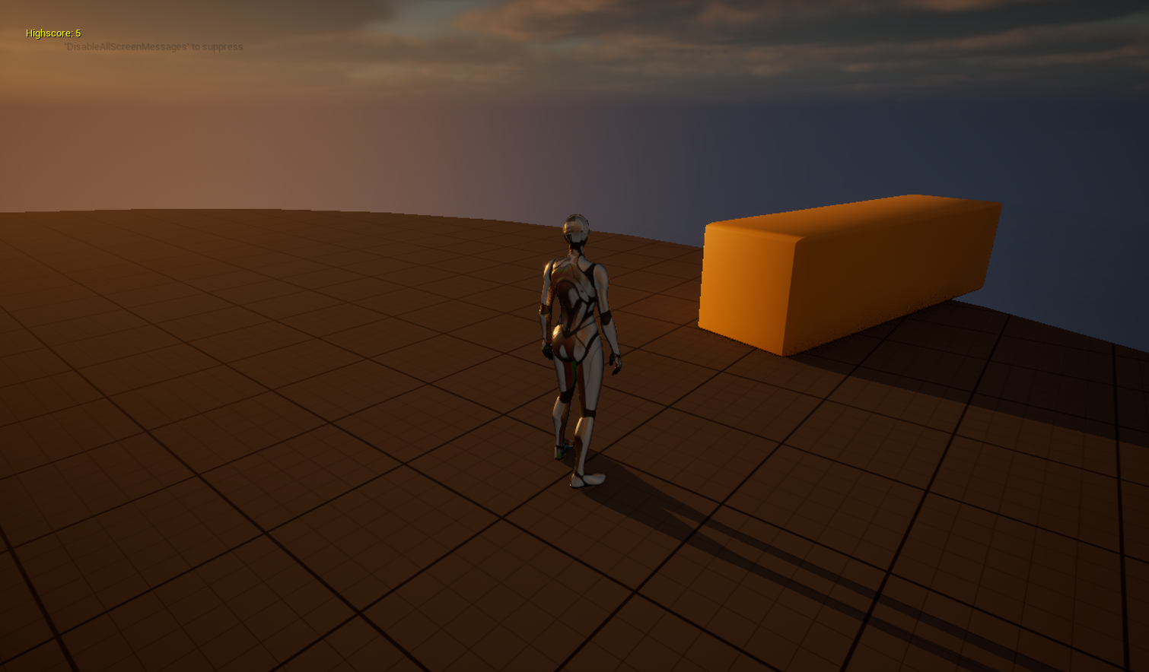

After resetting:

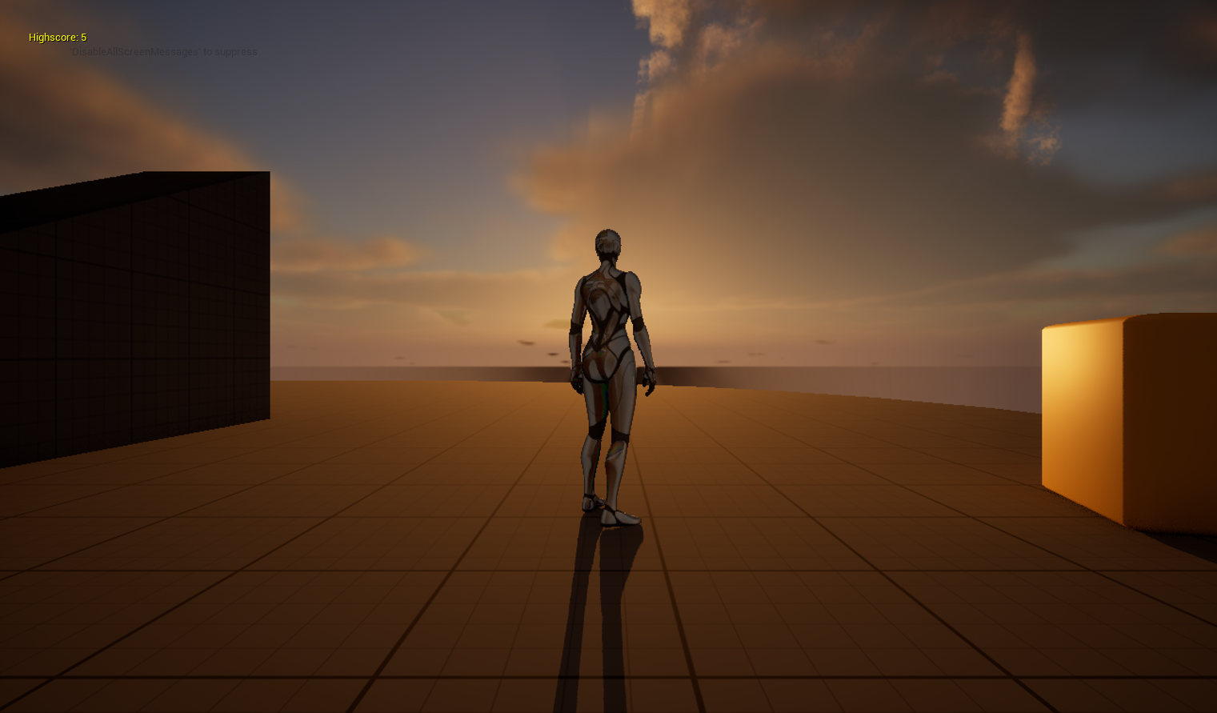

Player Position test:

The player position will be tested by checking if the position of the player is the same after resetting the game, once the player has moved.

Before resetting:

After resetting:

Actor Component test:

The actor component will be tested by checking if an object, in this case a yellow box, is in the same position after resetting the game, once it has been moved by the player.

Before resetting:

After resetting:

After testing, no further changes were necessary as everything worked as expected.